Junior University

June 12-June 23, 2017
8:30AM-12:30PM
$50.00 Field Trip/Lab Fee
Payable at time of application
Transportation must be provided by parents.

Exciting Courses
Advanced Math
Exploration of numbers and their impact on your life with technological focus.

ELA
Travel the world through reading and writing to unknown destinations.

Technology
Fine tune use of technology to succeed in school. Create your own electronic portfolio to share with your friends and family.

Science
Experiments and labs!

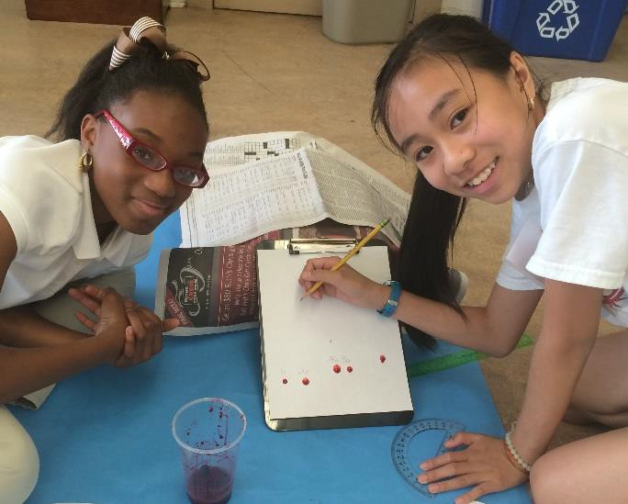

Enrollment is limited!!!!!

You must submit a completed application, teacher recommendation, essay, and $50.00 field trip/lab fee to reserve your spot!
Classes held at Savannah Arts Academy Students must be enrolled in grades 3-8 to be eligible to attend.

Bring your favorite snack!

Submit your completed application, teacher recommendation, essay, and $50.00 field trip/lab fee today to reserve your spot.

